**PROJECT PLANNING PHASE**

|  |  |
| --- | --- |
| Date | 22 October 2022 |
| Team ID | PNT2022TMID53703 |
| Project Name | IOT based Smart crop Protection System for agriculture |
| Maximum Marks | 8 Marks |

**Product Backlog, Sprint Schedule, and Estimation (4 Marks)**

Use the below template to create product backlog and sprint schedule

| **Sprint** | **Functional Requirement (Epic)** | **User Story Number** | **User Story / Task** | **Story Points** | **Priority** | **Team Members** |
| --- | --- | --- | --- | --- | --- | --- |
| Sprint-1 |  | US-1 | Create the IBM Cloud services which are being used in this project. | 6 | High | Harshavarshini  Aathiskumar  Karthick  Harikrishnan |
| Sprint-1 |  | US-2 | Configure the IBM Cloud services which are being used in completing this project. | 4 | Medium | Harshavarshini  Aathiskumar  Karthick  Harikrishnan |
| Sprint-2 |  | US-3 | IBM Watson IoT platform acts as the mediator to connect the web application to IoT devices, so create the IBM Watson IoT platform. | 5 | Medium | Harshavarshini  Aathiskumar  Karthick  Harikrishnan |
| Sprint-2 |  | US-4 | In order to connect the IoT device to the IBM cloud, create a device in the IBM Watson IoT platform and get the device credentials. | 5 | High | Harshavarshini  Aathiskumar  Karthick  Harikrishnan |
| Sprint-3 |  | US-1 | Configure the connection security and create API keys that are used in the Node-RED service for accessing the IBM IoT Platform. | 10 | High | Harshavarshini  Aathiskumar  Karthick  Harikrishnan |
| Sprint-3 |  | US-2 | Create a Node-RED service. | 10 | High | Harshavarshini  Aathiskumar  Karthick  Harikrishnan |
| Sprint-3 |  | US-1 | Develop a python script to publish random sensor data such as temperature, moisture, soil and humidity to the IBM IoT platform | 7 | High | Harshavarshini  Aathiskumar  Karthick  Harikrishnan |
| Sprint-3 |  | US-2 | After developing python code, commands are received just print the statements which represent the control of the devices. | 5 | Medium | Harshavarshini  Aathiskumar  Karthick  Harikrishnan |
| Sprint-4 |  | US-3 | Publish Data to The IBM Cloud | 8 | High | Harshavarshini  Aathiskumar  Karthick  Harikrishnan |
| Sprint-4 |  | US-1 | Create Web UI in Node- Red | 10 | High | Harshavarshini  Aathiskumar  Karthick  Harikrishnan |
| Sprint-4 |  | US-2 | Configure the Node-RED flow to receive data from the IBM IoT platform and also use Cloudant DB nodes to store the received sensor data in the cloudant DB | 10 | High | Harshavarshini  Aathiskumar  Karthick  Harikrishnan |

**Project Tracker, Velocity & Burndown Chart: (4 Marks)**

| **Sprint** | **Total Story Points** | **Duration** | **Sprint Start Date** | **Sprint End Date (Planned)** | **Story Points Completed (as on Planned End Date)** | **Sprint Release Date (Actual)** |
| --- | --- | --- | --- | --- | --- | --- |
| Sprint-1 | 20 | 6 Days | 24 Oct 2022 | 29 Oct 2022 | 20 | 29 Oct 2022 |
| Sprint-2 | 20 | 6 Days | 31 Oct 2022 | 05 Nov 2022 | 20 | 05 Nov 2022 |
| Sprint-3 | 20 | 6 Days | 07 Nov 2022 | 12 Nov 2022 | 20 | 12 Nov 2022 |
| Sprint-4 | 20 | 6 Days | 14 Nov 2022 | 19 Nov 2022 | 20 | 19 Nov 2022 |

**Velocity:**

Imagine we have a 10-day sprint duration, and the velocity of the team is 20 (points per sprint). Let’s calculate the team’s average velocity (AV) per iteration unit (story points per day)

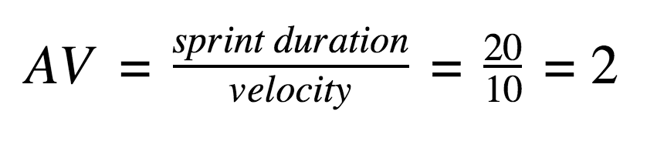

**Burndown Chart:**

A burndown chart is a graphical representation of work left to do versus time. It is often used in agile software development methodologies such as Scrum. However, burndown charts can be applied to any project containing measurable progress overtime.

